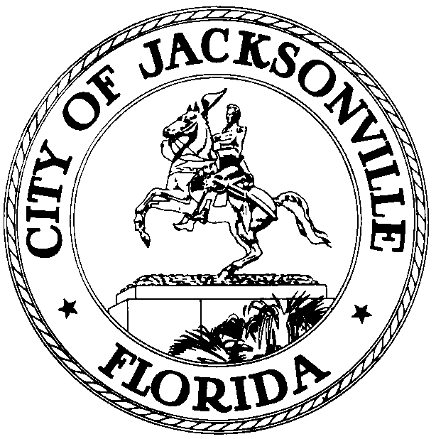

OFFICE OF THE CITY COUNCIL

Jacksonville Waterways Commission
117 W. Duval Street, Suite 425, Jacksonville, Florida 32202

December 3, 2019
1:00 PM

A M E N D E D M E M O R A N D U M

TO: Jacksonville Waterways Commission’s
Florida Inland Navigation District (FIND) Subcommittee

Raymond S. Pringle Jr.
Matt Brockelman – Excused
Marshall Adkison – Excused
Lindsey Brock

FROM: Jill Haskell, Chair

RE: Florida Inland Navigation District (FIND) Subcommittee Meeting

As Chair of the Florida Inland Navigation District (FIND) Subcommittee, I am hereby scheduling a meeting for Wednesday, December 4, 2019 at 1:30 p.m., in the Committee Room B, City Hall, 117 West Duval Street, 1st Floor, Jacksonville, FL 32202. The purpose of this meeting is to discuss the potential FIND projects for the 2020 grant cycle. All parties are welcome to attend.

Please mark your calendars accordingly.

JH/js

E-mail: Council Members/Staff
Cheryl Brown, Director/Council Secretary
Jessica Matthews, Chief, Legislative Services
Margaret M. Sidman, Deputy, General Council
Paige Johnston, Chief, General Counsel
Jeff Clements, Chief of Research
Susan Grandin, Asst. General Counsel
CITYC@COJ.NET
Posted Notice Board, 1st Fl, City Hall
Public Notice System, City Council Web Page
Media Box

